
ACTIVE LEARNING TEMPLATE: Growth and Development

STUDENT NAME

DEVELOPMENTAL STAGE Adolescent REVIEW MODULE CHAPTER

EXPECTED GROWTH AND DEVELOPMENT


Physical
Development

There is very little growth in terms of length the body is mainly developing physically. There is growth of pubic hairs and deepening of voice for men while the breast begins to form among the female adolescents.

Health promotion

Cognitive
Development

The thinking and reasoning capacity has fully develops. The adolescent has the ability to think on his own and to make decision which may not be responsible. There is ability of strong emotional feelings such as love and desires experienced towards the opposite sex.

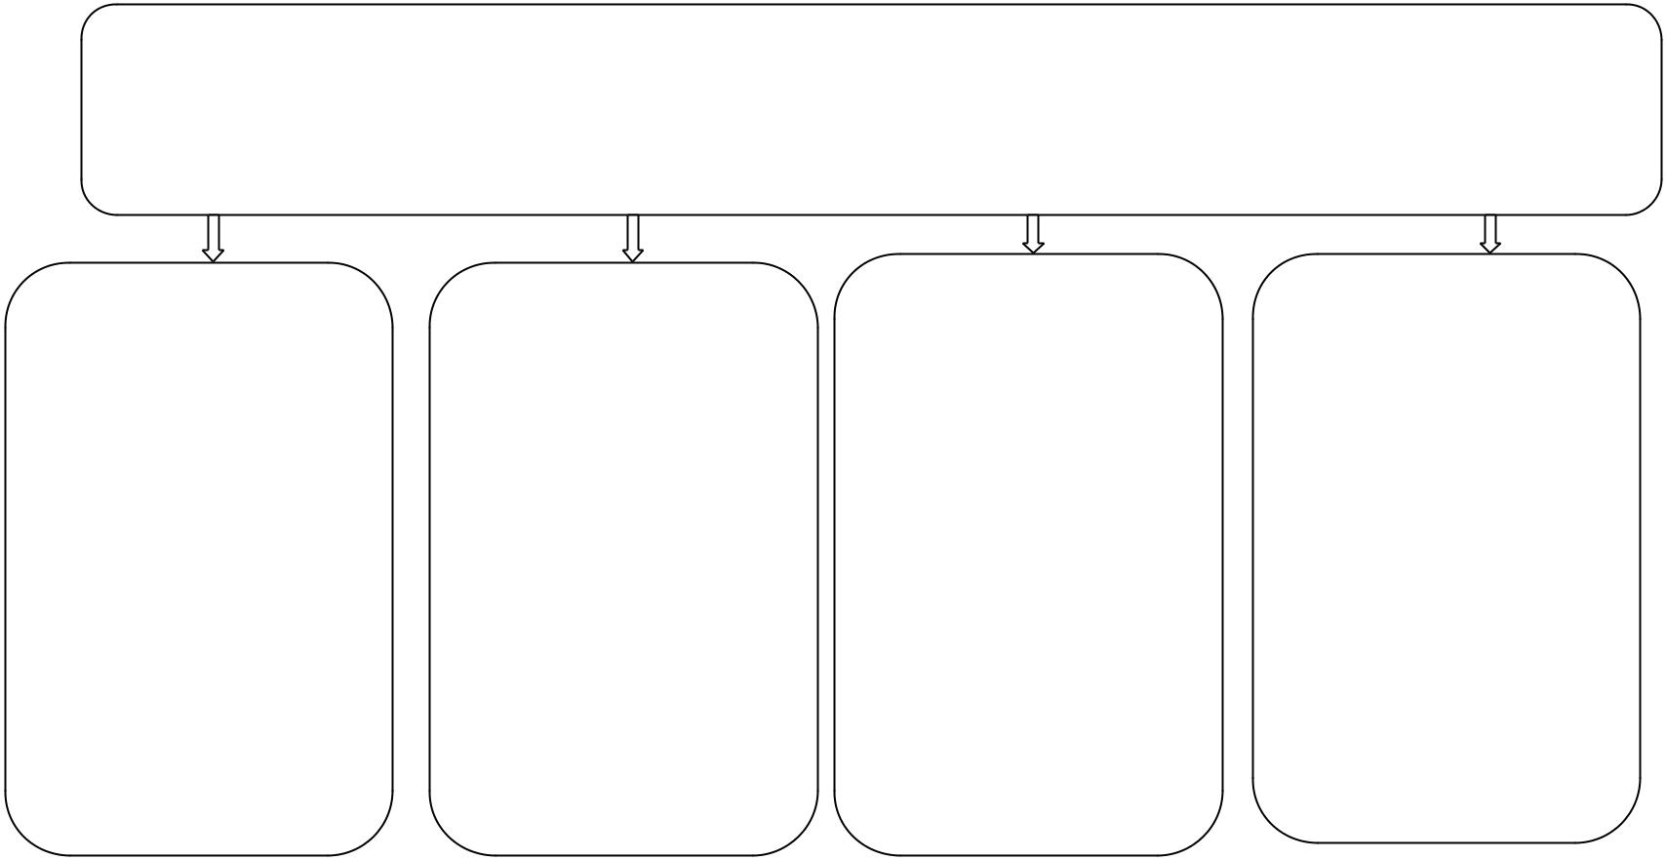

Psychological
Development

The adolescents require very high attention at this stage and they need to be recognized everywhere. There is very fragile self-esteem that the

adolescents have and have tendency of looking for approval. The emotional feelings and desires are highest among the adolescents due to high level of reproductive hormones.

Age- Appropriate Activities

The appropriate activities include walking playing football and biking

among others. It is recommended by CDC that media time be limited

Attention deficit disorder is a problem a facing adolescents other includes autistic disorder, Scoliosis, Urinary refusal among others .The problems faced by adolescents requires the attention of healthcare professional and other physicians (Onis, 2007).

Immunizations

Adolescents’ must be immunized of Varicella, chicken pox and mumps immediately after the age of 12 years

From the age of 12 years the adolescents should be able to receive the shots of mumps varicella virus and chicken pox.

Health Screening

Adolescents should be
routinely screened for
cervical cancer,
testicular screening,
blood pressure lipids

level and
cardiovascular
diseases. Early
detection of the any of
these diseases should

be recommended to the
physician.

Nutrition

Due to high activity the adolescent’s food portion should be very high in starch. Girls should eat food that improves the development of the reproductive system. Generally balance diet should be maintained for the Adolescents.
(Hills, 2007)

Injury Prevention

The adolescents should be closely monitored not to engage in violent activities that may physically put them in danger. Another danger is drug and substance abuse that is very high among the teen should be prevented.
(Malina, 2012).

ACTIVE LEARNING TEMPLATES THERAPEUTIC PROCEDURE A5

